In order to get the code to work, start the VBA editor from Outlook (Alt-F11), then create a new module in the VBA Project:

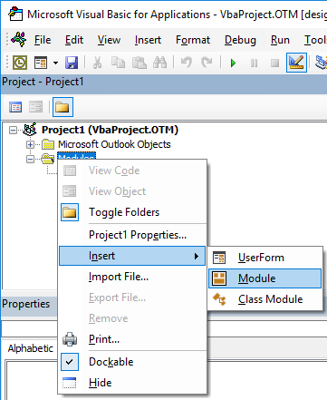

In this new module, copy the content of the VBA file in this project.

Then add the reference library for Excel objects to be manipulated from Outlook through the Tools|References menu :

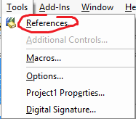

Then select your Microsoft Excel Object Library (the number will depend upon your version, but most all recent ones work) :

